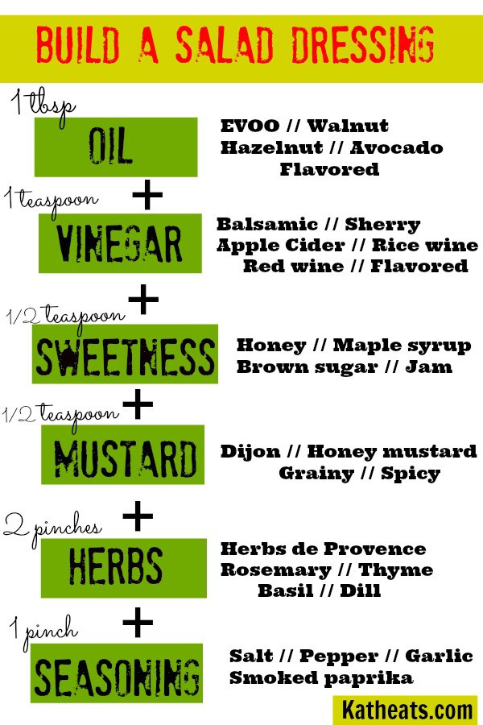
Generally the magic ratio of oil to vinegar is 3:1. This matters more if you’re making a big jar of dressing to keep on hand, but it’s a good ratio to shoot for in smaller batches too. Many people use way more vinegar than oil. The oil is what brings the luxurious richness to your salad, so while I agree it might not be smart to glug it on, using a little dressing prepared in the right ratio will bring out the best in your greens. Another good rule of thumb is to use 1 tablespoon of dressing for 1.5 cups of greens. You don’t want a soggy salad, and remember you can always add more after your first round of tossing. So if you have 6 cups of greens, that’s about a quarter cup of dressing.

